SAVIC MINERALS PTY LTD
DETAILS OF APPLICATION FOR EXPLORATIONLICENSE EL007725
1 September 2021

Notice of Application for Exploration Licence EL007725
Mineral Resources (Sustainable Development) Act 1990 (MRSDA) – Section 15(5)

1.Name and address of applicant
Savic Minerals Pty Ltd
19-25 Coral Sea Drive Mossman Gorge QLD 4873

2. Contact details of applicant for map and other information requests:

I.B.Campbell
Telephone: 0404 894 304
Email: savicminerals@gmail.com

3. Details of the application

Application No.: EL007725
Locality: 3km east of Edenhope, 6 km north-west of Harrow, 5km south of Ozenkadnook
Area of application 500 km2
Date of application: 05.08.2021

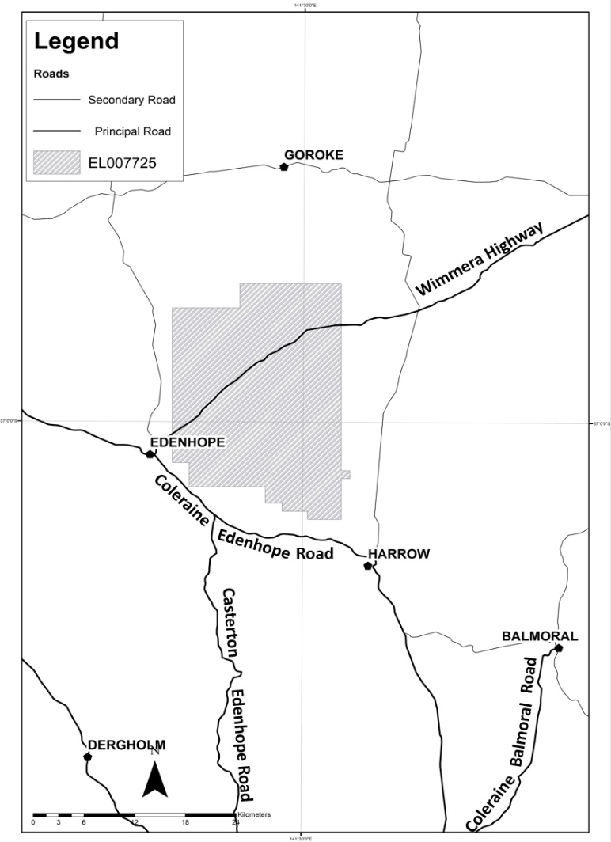

4. Objections
Any person may object to a licence being granted by:
- putting the objection or comment in writing; and
- including the grounds on which it is made.

Objections must be lodged within 21 days after the latest date on which the application was advertised and can be lodged online at https://rram.force.com/ObjectionSubmission or
posted to:
The Minister for Resources
c/- Manager Licensing
Earth Resources Regulation
GPO Box 4509
Melbourne Victoria 3001

It is recommended that objections are lodged online to ensure timely consideration.
https://rram.force.com/ObjectionSubmission

Enquiries can be made by writing to the Manager Licensing at the above address or
by phoning the Earth Resources Information Centre on 1300 366 356.

5. Other statutory requirements
a. Subject to other statutory requirements being satisfied, an exploration licence, if granted, entitles the holder of the licence to explore and search for minerals in the relevant land, but does not entitle the holder to undertake mining.
b. Further information regarding the statutory requirements that must be complied with
prior to work being undertaken is available on the department’s Community & Land Use page: https://earthresources.vic.gov.au/community-and-land-use

6. Outline of proposed work:
For the first year, low impact field exploration is planned to include historical research, modelling of existing data, field mapping, soil sampling, rock chipping with minimal impact on the environment.

Should future higher impact exploration activities be planned such as exploration drilling, it will involve a submission of a low impact exploration plan or work plan to Earth Resources Regulation, detailed rehabilitation plans, and monitoring and auditing.

Throughout the exploration planning process, Savic Minerals will consult with individual land holders and the broader community and provide information on planned exploration activities and allow opportunities for feedback to be incorporated into the planning process.

SAVIC MINERALS PTY LTD Commitment to Regulatory Exploration Processes, Sustainability, Community Involvement and Environmental Protection

Exploration Activities Exploration Licences are granted by the Victorian state government, usually for a period of five years. Mineral exploration is strictly regulated under the Mineral Resources (Sustainable Development) Act 1990 and enforced by Earth Resources Regulation (ERR), Victoria’s mineral regulatory authority.
Savic Minerals conducts low impact exploration activities in the initial stages of activity such as mapping, soil sampling and geophysical surveys to understand the mineralisation of an area. This restricts the removal of trees or clearing of any tracks or land, protecting native flora and fauna. We consult with relevant landowners and stakeholders prior to any exploration activity, including Crown land managers such as Parks Victoria or the Department of Environment, land, Water and Planning.
Low impact exploration includes the following activities:
Review of historical data and mapping of surface geology: If relevant maps are not available, handheld GPS navigators can be used to survey any areas and produce further geological maps that are needed.
Geophysical surveying uses electronic devices that measure the variation in the near surface rock formations such as gravity, magnetics or resistivity and electrical conductivity, and give us a deeper understanding of the underlying geology of the area. These surveys can be conducted on foot, by vehicle or by aircraft and are non-invasive.
Geochemical soil and rock sampling are used to discover the chemistry of the ground below. Our geologists collect small soil samples and rock chips from an area to send to laboratories for analyses, to determine the mineral content present. Soil samples are generally 300-500g and taken from 15-30cm depth. Rock chips are about the same size as the palm of your hand or smaller and taken from the surface of an area. The geologists record the locations of each sample with a handheld GPS and backfill any shallow soil coverings to their previous state.
Drilling Early-stage exploration drilling is low impact – it will not have any significant impact on nearby flora or fauna, and if possible, we will utilise existing tracks in the area.
Once our geologists have completed low-impact exploration, certain areas of interest may be identified for a more thorough drilling program, to help us understand more about the mineral content in the ground below. Any such drilling we undertake requires us to submit a Work Plan to Earth Resources Regulation. This must be reviewed and approved by a variety of government departments prior to the start of any drilling.
All Work Plans must include information on the following:
- heritage and environmental reviews, possible impacts, and relevant mitigations
- details on proposed works and methodology
- any landowner compensation agreements
- further administrative plans
Landowners and stakeholders are consulted before we access any areas for drilling, including Crown Land, with written permission and any compensation agreements required prior to the commencement of any drilling. Once we commence drilling, our crews will only operate during daytime to minimise risk to our people as well as reduce any noise or light exposure to nearby communities.
Exploration is Not a Licence to Mine
An Exploration Licence does not allow any mining activities. Mining falls under a different licencing and approval process within the ERR and approval must be granted for any mining activities to occur. The application process for a mining licence can take 10-15 years and involves extensive community consultation prior to approval.
More information: Code of Practice for Mineral Exploration, Appendix 2. www.earthresources.vic.gov.au
Community Amenity and Involvement

Savic Minerals are committed to complying with all Environmental Protection Policies outlined by the Environmental Protection Authority Victoria.
We undertake numerous controls to reduce any impact resulting from our exploration activities on community amenity, as outlined in the Code of Conduct for Mineral Exploration.
Our activities are planned and executed with the priority of minimising any impact on community amenity. By having open conversations and discussions with community members, we can work together to ensure we achieve best practice. More information: Code of Practice for Mineral Exploration www.earthresources.vic.gov.au
Rehabilitation
Rehabilitation is an integral part of exploration and ensures that the environment can continue to thrive after exploration work is completed.
Savic Minerals works in accordance with the guidelines by the Victorian Government and will facilitate effective rehabilitation of any disturbed areas. No wetlands, waterways or lakes will be impacted by our activities.
We will enter into rehabilitation agreements with landholders or stakeholders to ensure sites are rehabilitated to all mutually agreed conditions. Any significant vegetation is identified and fenced off before any work can commence. More information: Code of Practice for Mineral Exploration Part C – 26. www.earthresources.vic.gov.au

Fire Preparedness.
The company works closely with local Country Fire Authority (CFA) brigades when planning and conducting our exploration programs to reduce any chances of a fire occurring. This is particularly important over the summer period.
Fire protection and preparedness is regulated by Worksafe and Earth Resources Regulation under the Occupational Health and Safety Act (2004) and Forests (Fire Protection) Regulations 2014.
https://www.emergency.vic.gov.au/respond/
http://www.bom.gov.au/vic/warnings/
More information: Code of Practice for Mineral Exploration, Part C – 14. www.earthresources.vic.gov.au

Water Use
If water is required in the exploration drilling phase to lubricate drilling equipment, it will be sourced from available water supplies located nearby. This requires permission from the local authorities, such as local catchment authorities and local governments or shires. The company will seek permission from the relevant authorities prior to any water use. In some drill holes, groundwater may also be intersected in the drilling process, which can supplement any water requirement.
Excess water that returns to surface during drilling is captured and recycled back down the drill hole to minimise any water consumption. Tanks are used to capture the water that is returned to surface and these act as a buffer in the water supply cycle, thus the process is fully self-contained.
For more information on the license requirements refer to DEDJTR Code of Practice for Mineral Exploration.

